

# COLLEGE OF BUSINESS STUDIES

# SESSION- 2024-2026

# POWER BI PROJECT REPORT

# ON

# AMAZON SALES DATA

# MBA ‘B’

## SUBMITTED TO: SUBMITTED BY:

**Dr. Sourabh Poswal Vaishnavi Parasar**

**Neelakshi Kansal**

**Gungun**

Acknowledgment

I would like to express my heartfelt gratitude to everyone who contributed to the successful completion of this report on ‘Amazon Sales Data analysis’. Firstly, I extend my sincere appreciation to my faculty guide, Dr. Sourabh Poswal , for their invaluable guidance, support, and expertise throughout this project. Their insights and constructive feedback significantly enriched the analysis and enhanced my understanding of the subject matter.

I also wish to thank my peers and colleagues for their encouragement and collaborative spirit, which made this project more enjoyable and productive.

Furthermore, I acknowledge the importance of the data sourced from the online Excel sheet, which provided a robust foundation for this analysis. Lastly, I appreciate the resources and tools, which facilitated the successful execution of this project.

This report reflects the collective efforts of all those involved, and I am grateful for the support and collaboration that made it possible.

EXCLUSIVE SUMMARY

The Power BI process enabled Amazon to effectively analyze its sales and fulfillment data, providing valuable insights into performance trends, customer behavior, and operational bottlenecks. The dashboard was designed to offer interactive, real-time data visualizations, highlighting key metrics such as sales trends, average sales per order, and delivery delays. Data modeling was performed to clean, structure, and create relationships between various datasets, facilitating more detailed analysis. The analysis led to business recommendations that included focusing on high-performing product categories, addressing delivery delays in merchant fulfillment, leveraging seasonal sales peaks, and improving customer service in regions with high cancellation rates. Despite its effectiveness, the process had limitations such as data granularity, scalability issues, and exclusion of external factors, which could impact the comprehensiveness of the insights. Nonetheless, the Power BI analysis empowered Amazon to make data-driven decisions, optimizing sales strategies and operational efficiency for better business outcomes.

INTRODUCTION

# Project Overview

The purpose of this report is to analyze Amazon's sales data and fulfillment processes to gain actionable insights into customer spending, product performance, and operational efficiency. By leveraging Power BI dashboards, this report evaluates key aspects such as revenue by category, delivery delays, order fulfillment efficiency, and regional sales performance.

Amazon operates a complex e-commerce ecosystem where customer satisfaction is influenced heavily by product availability, fulfillment speed, and accuracy. The project’s scope focuses on understanding:

* How sales performance varies across different categories and channels.
* How fulfillment methods (Amazon vs. Merchant) impact delays and customer experience.
* Regional disparities in sales and order cancellations.

The findings aim to provide a holistic view of Amazon's operations and help identify strategies to optimize fulfillment processes, reduce delivery delays, and maximize revenue.

# Objectives of the Analysis

This analysis is driven by the following key objectives:

* **Improve Fulfillment Efficiency:**

Analyze the differences between Amazon-fulfilled and Merchant-fulfilled orders, focusing on delivery delays and order cancellations. Insights will help refine operations to improve delivery speed and reduce delays.

* **Understand Customer Spending Patterns:**

Identify which product categories and sales channels generate the most revenue. The analysis will support targeted marketing campaigns for high-performing categories and channels.

* **Optimize Regional Operations:**

Evaluate regional sales performance and identify areas with high order cancellations or underperformance. These insights can inform regional marketing and logistics strategies to enhance growth.

* **Enhance Revenue Generation:**

Determine revenue trends by category and fulfillment method. By identifying high-performing categories, the company can focus on scaling them further while addressing challenges in lower-performing categories.

* **Strategic Decision-Making:**

Provide actionable insights to the business for long-term improvements in fulfillment processes, product offerings, and regional sales strategies.

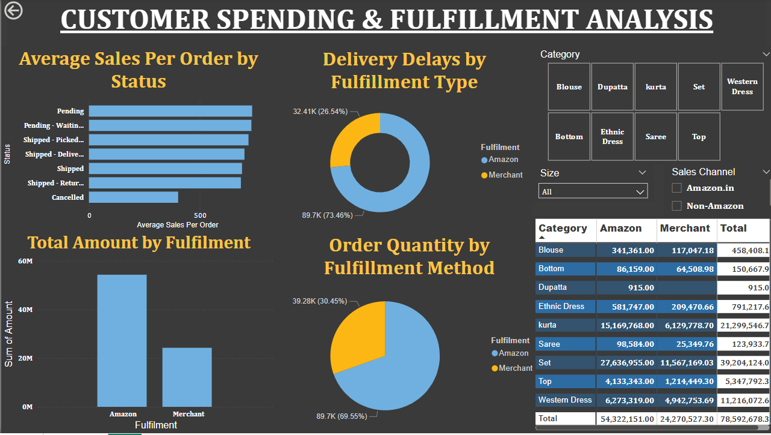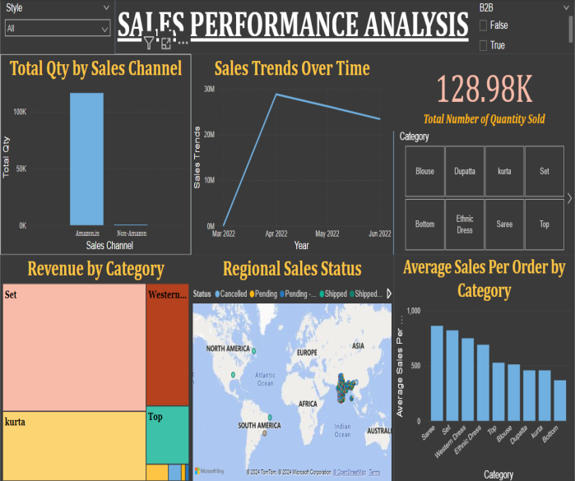

DATA OVERVIEW

## Data Source

The data used in this analysis is sourced from internal Amazon sales and fulfillment records, visualized through Power BI dashboards. Key data sources include:

* **Sales Transactions**: Information on total sales, order quantities, and revenue by category and channel.
* **Fulfillment Records**: Data on order status (e.g., shipped, pending, canceled) and delivery timelines, segmented by Amazon Fulfillment and Merchant Fulfillment.
* **Regional Sales Data:** Geographic distribution of sales, cancellations, and fulfillment delays.
* **Product Categories:** Classification of items into categories such as Sarees, Western Dresses, Sets, and more.
* **Sales Channels:** Breakdown of sales generated from Amazon.in versus Non-Amazon platforms.

This data provides a comprehensive view of Amazon's operations, focusing on both performance metrics and process inefficiencies.

## Data Description

The dataset comprises key variables to evaluate sales performance and fulfillment efficiency:

#### Fulfillment Method:

* **Amazon Fulfillment:** Orders fulfilled directly by Amazon.
* **Merchant Fulfillment:** Orders fulfilled by third-party sellers.
* **Order Status:** Categories such as shipped, pending, canceled, returned, and delivered.
* **Product Categories:** Includes various items like Sarees, Blouses, Western Dresses, Sets, etc.
* **Sales Channels:** Distinction between Amazon.in and Non-Amazon sales platforms.
* **Performance Metrics:** Revenue, quantity sold, average sales per order, and delivery delays.

The dataset is organized to show aggregated insights at category, regional, and fulfillment levels, enabling targeted analysis of high-performing and underperforming segments.

## Data Preparation

To ensure accuracy and relevance in the analysis, the following steps were taken during data preparation:

#### Data Cleaning

* Removed incomplete or duplicate records, especially those with missing fulfillment statuses or sales values.
* Standardized order statuses to uniform labels (e.g., "Pending" vs. "Pending - Waiting" consolidated).

#### Data Aggregation:

* Summarized sales and revenue data by category, channel, and region.
* Created total and average metrics for better comparisons (e.g., total revenue, average sales per order).

#### Data Transformation:

* Categorized fulfillment delays by type (Amazon vs. Merchant).
* Segmented sales data into geographic regions for regional performance mapping.

#### Visualization Readiness:

* Organized data to enable dynamic visualization using Power BI, ensuring interactive filtering for categories, channels, and fulfillment types.
* These steps ensured a structured and reliable dataset, enabling actionable insights into sales, fulfillment, and operational performance.

DATA ANALYSIS

# Sales Performance Analysis

## 1. Total Quantity by Sales Channel

This analysis highlights the distribution of order quantities across different sales channels: Amazon.in and Non-Amazon platforms.

### Findings:

* The majority of sales (over 90%) occur through Amazon.in, while Non-Amazon channels account for a significantly smaller proportion.
* Amazon.in's dominance suggests the platform’s strong brand loyalty, effective marketing, and superior infrastructure compared to external platforms.

### Insights:

Efforts should focus on further strengthening Amazon.in’s ecosystem while exploring strategies to boost performance on external platforms.



## 2. Sales Trends Over Time

Analyzing monthly sales trends reveals patterns in revenue growth and seasonal performance.

### Findings:

* A sharp increase in sales is observed between March and April, potentially due to promotional campaigns, new product launches, or seasonal demand.
* Sales decline after April, indicating possible post-peak season slowdowns or logistical challenges.

### Insights:

To sustain momentum, Amazon could implement mid-year promotional events and explore ways to address any operational bottlenecks during slower months.

## 3. Revenue by Category

This section evaluates which product categories drive the highest revenue.

### Findings:

* Top-Performing Categories: Sets, Western Dresses, and Sarees generate the highest revenue. These categories benefit from high order volumes and strong customer demand.
* Low-Performing Categories: Categories such as Dupattas and Blouses show lower revenue, likely due to lower price points or niche appeal.

### Insights:

By investing in high-demand categories, Amazon can maximize profitability. Promotions or bundling strategies could uplift sales in low-performing categories.



## 4. Regional Sales Status

Regional analysis examines how sales performance varies geographically.

### Findings:

* North America and Asia account for the highest sales volumes, reflecting their importance as core markets.
* Higher cancellation rates in specific regions suggest regional logistical issues or customer dissatisfaction with local fulfillment.

### Insights:

Targeted interventions such as regional inventory optimization and enhanced customer support can address high cancellation rates and improve regional sales performance.



## 5. Average Sales per Order by Category

This metric helps evaluate how much revenue each order generates across categories.

### Findings:

* Categories like Sarees, Sets, and Western Dresses show the highest average sales per order, likely driven by higher price points or bulk purchases.
* Lower averages for Blouses and Dupattas suggest these items are frequently purchased as add-ons or have lower price tags.

### Insights:

To maximize order value, Amazon can upsell or cross-sell high-value items alongside lower-performing categories, such as pairing blouses with sarees.



# Customer Spending and Fulfillment Analysis

## 1. Average Sales per Order by Status

This analysis identifies how order statuses impact average sales.

### Findings:

* Shipped and Delivered Orders: These statuses contribute the highest average sales, underscoring the importance of completing orders efficiently.
* Pending and Canceled Orders: Lower sales averages in these statuses suggest the negative impact of incomplete or failed transactions.

### Insights:

By prioritizing operational improvements to move pending orders to completion and reducing cancellations, Amazon can enhance revenue.



## 2. Delivery Delays by Fulfillment Type

This section examines the relationship between fulfillment type (Amazon vs. Merchant) and delivery delays.

### Findings:

* Amazon Fulfillment accounts for 73.46% of delivery delays, reflecting its higher order volume. However, its infrastructure helps manage delays better compared to Merchant Fulfillment.
* Merchant Fulfillment experiences a disproportionately higher share of delays relative to its volume, impacting customer satisfaction.

### Insights:

Encouraging merchants to use Amazon Fulfillment or improving third-party logistics partnerships could significantly reduce delays.



## 3. Total Amount by Fulfillment

This metric evaluates revenue contribution by fulfillment type.

### Findings:

* Amazon Fulfillment generates significantly higher revenue compared to Merchant Fulfillment, highlighting its dominance in the sales process.
* The disparity reflects customer preference for reliable fulfillment and the scalability of Amazon’s infrastructure.

### Insights:

Continued investment in Amazon Fulfillment, such as warehouse expansion and logistics optimization, can further increase revenue and enhance customer trust.



## 4. Order Quantity by Fulfillment Method

This analysis compares the number of orders handled by Amazon Fulfillment versus Merchant Fulfillment.

### Findings:

* Amazon Fulfillment handles 69.55% of total orders, confirming its position as the preferred fulfillment method.
* Merchant Fulfillment accounts for 30.45%, suggesting room for improvement in its efficiency and reliability.

### Insights:

Offering incentives to merchants for using Amazon Fulfillment, such as cost reductions or better visibility for their products, can shift a greater share of orders to the Amazon network, improving overall efficiency.



Power BI Process

## 1. Dashboard Design

The dashboard was designed to provide interactive insights into Amazon’s sales and fulfillment data using:

* Visuals: Bar charts, pie charts, line graphs, treemaps, and maps.
* Filters: Options for categories, sales channels, sizes, and fulfillment methods.
* KPIs: Highlighted metrics like total revenue, average sales per order, and delivery delays.

## 2. Data Modeling

Structured raw data into a relational model by:

* Cleaning duplicates and inconsistencies.
* Creating relationships between orders, categories, and regional data.
* Using DAX formulas for metrics like revenue, average sales, and delivery delays.

## 3. Visualization

Data was presented through dynamic, interactive visuals, including:

* Bar Charts: Category and fulfillment performance.
* Pie Charts: Order and delivery delay distribution.
* Line Graphs: Sales trends over time.
* Maps and Treemaps: Regional and category-wise revenue.

Business Recommendations

1. **Focus on High-Performing Categories**: Amazon should prioritize categories like Sarees, Western Dresses, and Sets, ensuring strong inventory management and targeted promotions to maintain high sales and maximize revenue during peak times.
2. **Address Delivery Delays in Merchant Fulfillment:** To reduce delays, Amazon should incentivize third-party sellers to adopt Amazon Fulfillment services, ensuring faster, more reliable deliveries, which will enhance customer satisfaction and reduce negative feedback.
3. **Leverage Seasonal Sales Peaks:** By planning marketing campaigns and special offers during high-demand months like March and April, Amazon can capitalize on seasonal sales peaks, boosting revenue and maintaining strong sales momentum throughout the year.
4. **Improve Customer Support in High-Cancellation Regions**: Amazon should focus on enhancing fulfillment and communication in regions with high order cancellations, addressing customer concerns promptly and offering solutions to improve satisfaction and reduce cancellations.
5. **Optimize Inventory Management for Non-Amazon Sales Channels:** Amazon can optimize inventory for third-party platforms to increase sales in external channels, ensuring better product availability and maximizing overall sales across different platforms.

Limitations

1. **Data Granularity:** The analysis focused on aggregated sales and fulfillment metrics, limiting insights into individual customer behaviors and transaction-level details.
2. **Scalability Issues:** Handling Amazon's vast and growing dataset required optimization techniques like aggregation and partitioning to ensure fast performance in Power BI, especially as data volumes increase.
3. **Exclusion of External Data**: The analysis was based solely on internal Amazon sales data and did not incorporate external market trends, competitive analysis, or macroeconomic factors that could have provided a broader context.
4. **Limited Depth on Customer Segmentation:** The analysis did not explore deeper customer segmentation or preferences, which could have helped tailor strategies more precisely to different customer groups.
5. **Dependency on Historical Data:** The insights were based on historical data, which may not fully capture future trends or changes in market conditions, potentially leading to less accurate projections.

Conclusion

In conclusion, the Power BI process effectively transformed raw Amazon sales data into actionable insights, helping Amazon optimize its sales strategy, improve fulfillment operations, and drive customer satisfaction. By visualizing key metrics such as sales trends, fulfillment performance, and regional sales status, Power BI allowed stakeholders to make data-driven decisions that could directly impact Amazon's business growth. However, to gain a more comprehensive understanding of market dynamics and refine its strategies further, Amazon should consider integrating external market data and addressing data granularity issues. Despite these limitations, Power BI remains a powerful tool for Amazon's ongoing data analysis needs, enabling informed decision-making and operational efficiency.